Gold Standard for the Global Goals
PoA Design Consultation Report

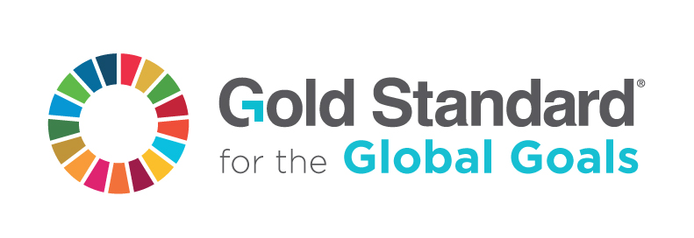

Sept 2020, Version 1

.1
KEY PROJECT INFORMATION
GS ID of PoA
Title of PoA
GS ID (s) of C/VPA (s) submitted at PoA Preliminary Review
Version number of the DCR
Completion date of version
Time of First Submission Date
Tentative Implementation date of the Programme
Design Consultation Start and End Date
Date of any Physical Meeting (s)

SECTION A. DESIGN OF STAKEHOLDER CONSULTATION

A.1. Description of the consultation methods used

>>Describe all methods used, explicitly stating whether a physical meeting was organized, if feedback was collected electronically, or a combination of both.

A. 2.
Information Made Available to Stakeholders

>> Report on the key programme information shared with stakeholders, including: details of each technology/practice covered by the Programme, the implementation plan, consultations planned (e.g. at programme or VPA/CPA level only), geographical scope of the programme, entities involved, interaction with other similar initiatives/programmes in overlapping geographical boundaries.

A.3. Invitation/consultation tracking table

>> A Gold Standard representative should be invited by email help@goldstandard.org

Organisation  (if relevant) | Name of invitee | Method of invitation | Date of invitation (>30 days before any meeting or e-consultation) | Date of Follow up  (essential for e-consultations)

SECTION B. OUTCOME OF THE CONSULTATION PROCESS

B.1. Assessment of comments received

Organization | Stakeholder comment | Was comment taken into account (Yes/ No)? | Explanation (Why? How?)

B.2. Report on Level of consultations

>> Feedback obtained from stakeholders on the level of consultation proposed (i.e. whether activity level stakeholder consultations should be carried out, or if a programme consultation is sufficient)

B.3. Summary of changes to the Programme design based on stakeholder feedback received.
>> This must account for potential synergies and conflicts identified with similar programmes and for any feedback on the level of consultations proposed.

Version | Date | Remarks
1.1 | Sept 2020 | Addition of version history table  Removal of Section A which repeats information in the POA-DD  Clarification on reporting information made available for stakeholders  Clarity on minimum period for invitation and consultation and that follow up is necessary for e-consultations  Clarity that a GS representative should be invited
1 | 10 July 2017 | Initial adoption

