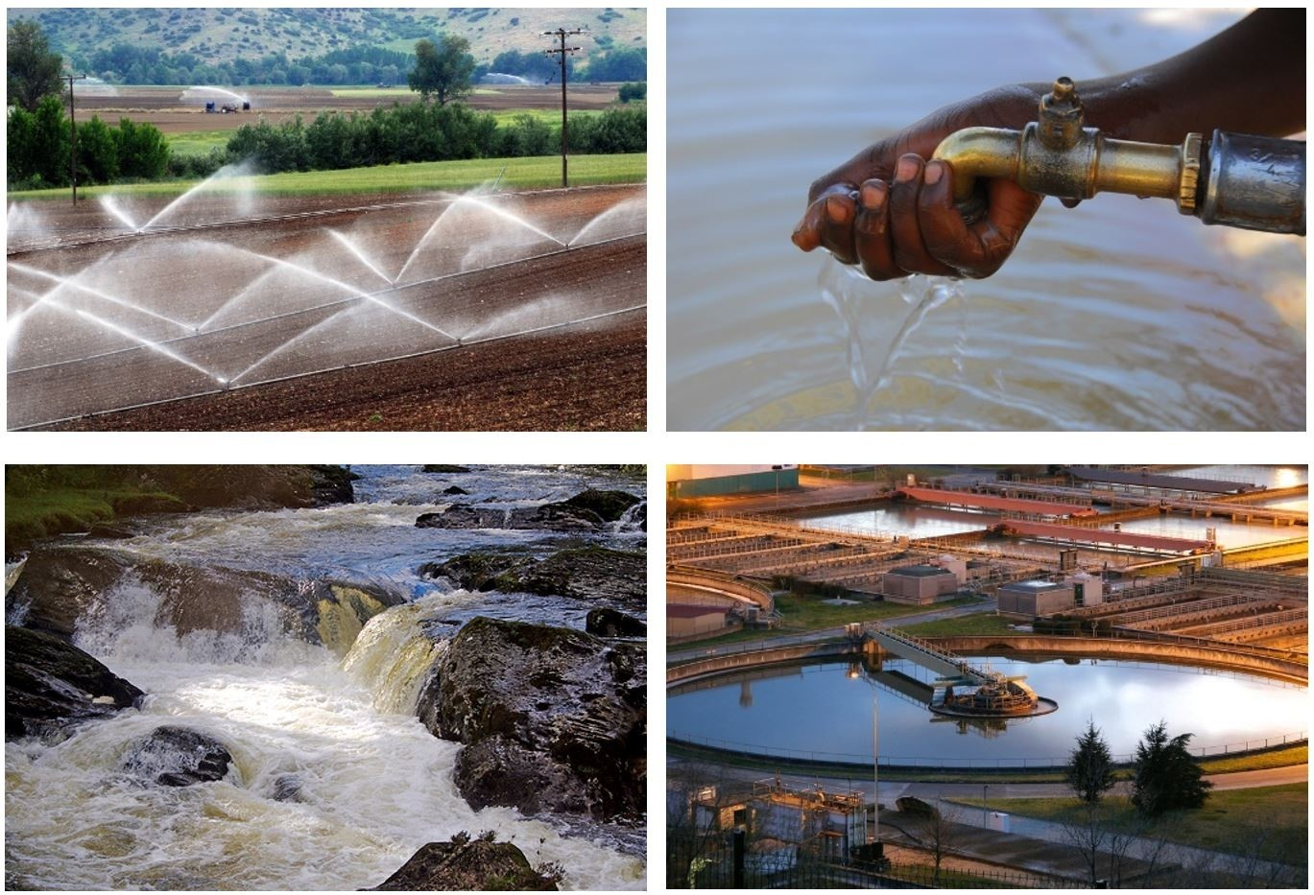

The Gold Standard Water Benefit Standard
Local Consultation Template (beta)

Project Title
...
Registry ID
...
Type of Certification
☐ Initial Certification ☐ Performance Certification

Design of physical meeting(s)
Agenda
...
Ensure that at least the following points are covered, but feel free to add more points as needed:
- Opening of the meeting
- Explanation of the project; based on the content of the ‘Key Project Information’
- Discussion of continuous input and grievance mechanism
- Questions for clarification about the project
- Blind ‘Sustainability Assessment’ exercise
- Discussion on monitoring the mitigation measures
- Closure of the meeting

Invitation tracking table

Category code | Organisation | Name of | Way of | Date of | Confirmation
 | (if relevant) | invitee | invitation | invitation | received? Y/N
... See definitions of the  WBS Requirements. | ... | ... | ... | ... | ...

Describe your selection
...
Explain how you decided that the above organisations/individuals are relevant stakeholders to your project.
Also, please discuss how your invitation methods seek to include a broad range of stakeholders (e.g. gender, age, ethnicity).

Text of individual invitations
...

Description of other consultation methods used
...
If individuals or entities (e.g. NGOs) are unable to attend the physical meeting, please discuss other methods that were used to solicit their feedback/comments (e.g. questionnaires, phone calls, interviews etc).

Participants in physical meeting(s)

Reference ID to the original participants list
...
Additional comments
…

Participants list
Date and time | ...
Location | ...
Category Code | Name of participant, job/ position in the community | Male/Female | Signature | Organisation  (if relevant)
... | ... | ... | ... | ...

Evaluation forms

Reference ID to the original ‘evaluation forms’
...
Additional comments:
…

Summarise the main comments in the table below (please translate into English if necessary).
Provide references to the individual ‘evaluation forms’.
What is your impression of the meeting? | …
What do you like about the project? | …
What do you not like about the project? | …

Pictures from physical meeting(s)
...

Outcome of consultation process

Minutes of physical meeting(s)
...
Ensure that you include a summary of the meeting, as well as all comments received. Also include an outline of the discussions on continuous input and grievance expression methods; comments, agreements or modifications suggested by stakeholders.

Minutes of other consultations
...

Assessment of all comments

Stakeholder comment | Was comment taken into account (Y/N) | Explanation (Why? How?)
... | ... | ...

Summary of alterations based on comments
...
If stakeholder comments have been taken into account and any aspect of the project modified, then please discuss that here.

Sustainability Assessment
Summary of Sustainable Development Assessment of the stakeholders - BLIND exercise:

Watershed Risk Assessment
1.1 | Is the project’s physical area of influence (e.g. basin, watershed) in a water stressed or water scarce region?  The project is required to provide verifiable evidence of water stress experienced in the basin in which the project is active, and demonstrate that consumption of water by the project will bring positive impacts or, at minimum, not increase the overall annual basin stress.
Answer | Yes No (delete not applicable answer)
Explanation of answer | Provide explanation to support answer including sources and methods used, reasons for choice of sources and methods, estimation of impact, etc.

1.2 | If the project is involved in abstraction from a water source in a water scarce area, is it returning more than 80% of the abstraction to the watershed with the same or improved quality of water?  Where more rigorous assessment tools are unavailable, the project is required to demonstrate 80% return flow.
Answer | Yes No (delete not applicable answer)
Explanation  of answer | Provide explanation to support answer including sources and methods used, reasons for  choice of sources and methods, estimation of impact, etc.

1.3 | Will the project exacerbate and therefore contribute to any negative impacts to the natural pattern of the watershed such as high seasonal flow variability, flooding potential, lack of aquatic connectivity, drought, or climate change?  The risk of the project negatively impacting the watershed shall be assessed and addressed to ensure its ongoing, long-term viability and impact on surrounding social-economic and environmental assets.
Answer | Yes No (delete not applicable answer)
Explanation of answer | Provide explanation to support answer including sources and methods used, reasons for choice of sources and methods, estimation of impact, etc.

1.4 | Is the project's area of influence susceptible to erosion and/or water body instability?  If yes, the risk of the project negatively impacting the watershed and risks impacting project success shall be assessed and addressed to ensure its ongoing, long-term viability and impact on surrounding social-economic and environmental assets through an assessment of the sensitivity of physical area of influence due to low percentage of impervious cover in a project’s physical area of influence (e.g. basin, watershed), susceptibility to erosion and water body instability, and lack of terrestrial habitat connectivity.
Answer | Yes No (delete not applicable answer)
Explanation of answer | Provide explanation to support answer including sources and methods used, reasons for choice of sources and methods, estimation of impact, etc.

1.5 | Does the project boundary and its 25 km radius contain largely intact or High Conservation  Value (HCV) ecosystems, landscapes, key biodiversity areas, or sites, e.g. Ramsar wetlands, World Heritage Areas, 'wilderness' areas, free-flowing rivers, unique or species-rich areas, threatened or endangered species, migratory species as defined by treaties and national authorities or areas of natural cultural significance?  If yes, the risk of the project negatively impacting the watershed and risks impacting project success shall be assessed and addressed to ensure its ongoing, long-term viability and impact on surrounding HCV and ecological assets.
Answer | Yes No (delete not applicable answer)
Explanation of answer | Provide explanation to support answer including sources and methods used, reasons for choice of sources and methods, estimation of impact, etc.

1.6 | Is the projects’ area of influence likely to undergo significant socio-economic or environmental change directly relevant to the project intervention and objectives during the issuance period?  If yes, the risk of the project negatively impacting the watershed and risks impacting project success shall be assessed and addressed to ensure its ongoing, long-term viability and impact on surrounding social-economic and environmental assets.
Answer | Yes No (delete not applicable answer)
Explanation of answer | Provide explanation to support answer including sources and methods used, reasons for choice of sources and methods, estimation of impact, etc.

1.7 | Is the projects’ area of influence likely to impact environmental water flows required to sustain freshwater and estuarine ecosystems and the human livelihoods and well-being that depend on these ecosystems?  The project is required to ensure that daily flow variations (including the projects’ existing impacts) are less than 20%.
Answer | Yes No (delete not applicable answer)
Explanation of rating | Provide explanation to support answer including sources and methods used, reasons for choice of sources and methods, estimation of impact, etc.

Sustainability Assessment

1 Human rights and socio-economic condition
1.1 | The project respects internationally proclaimed human rights including universal access to water, dignity, cultural property and uniqueness of indigenous people. The project is not complicit in Human Rights abuses.
Rating | - 0 + E NR (delete all not applicable ratings)
Requirement | The project(s) shall respect existing water usages and rights of local communities. No discriminatory rights, tariffs, or access included in project designs, financial plans, or operations plans
Explanation of rating | Provide explanation to support rating including sources and methods used, reasons for choice of sources and methods, estimation of impact, etc.

1.2 | Legal rights, customary rights, special cultural, ecological, economic, religious or spiritual significance of indigenous peoples and local communities are assured by the project.
Rating | - 0 + E NR (delete all not applicable ratings)
Requirement | No transfer of control, involuntary relocation, or restricted access directed in PDD, policies and procedures, or operations plans.
Explanation of rating | Provide explanation to support rating including sources and methods used, reasons for choice of sources and methods, estimation of impact, etc.

2. Working Conditions
2.1 | Workers shall be able to establish and join labour organizations.
Rating | - 0 + E NR (delete all not applicable ratings)
Requirement | Minimum: There shall not be forced labour3.
Explanation of rating | Provide explanation to support rating including sources and methods used, reasons for choice of sources and methods, estimation of impact, etc.

2.2 | Working agreements with all individual workers shall be implemented.
Rating | - 0 + E NR (delete all not applicable ratings)
Requirement | Minimum: Workers and labour organizations shall be generally satisfied with their working agreements. These shall at minimum comprise:  - working hours, AND  - duties and tasks, AND  - remuneration, AND  - modalities on health insurance, AND  - modalities on termination of the contract.
Explanation of rating | Provide explanation to support rating including sources and methods used, reasons for choice of sources and methods, estimation of impact, etc.

2.3 | The project will uphold the ILO Fundamental Conventions3.
Rating | - 0 + E NR (delete all not applicable ratings)
Requirement | As stated
Explanation of rating | Provide explanation to support rating including sources and methods used, reasons for choice of sources and methods, estimation of impact, etc.

2.4 | Workers shall be informed in a workshop about their rights according to the 8 ILO  Fundamental Conventions.
Rating | - 0 + E NR (delete all not applicable ratings)
Requirement | As stated
Explanation of rating | Provide explanation to support rating including sources and methods used, reasons for choice of sources and methods, estimation of impact, etc.

2.5 | There shall be no child labour. Excepted are children for work on their families’ property as long as:  - their compulsory schooling (minimum of 6 schooling years) is not hindered, AND  - the tasks they perform do not harm their physical and mental development.
Rating | - 0 + E NR (delete all not applicable ratings)
Requirement | As stated
Explanation of rating | Provide explanation to support rating including sources and methods used, reasons for choice of sources and methods, estimation of impact, etc.

2.6 | Workers below the age of 18 year shall not work during night hours.
Rating | - 0 + E NR (delete all not applicable ratings)
Requirement | As stated
Explanation of rating | Provide explanation to support rating including sources and methods used, reasons for choice of sources and methods, estimation of impact, etc.

2.7 | Workers shall:  - be compensated for their overtime, AND  - not work in excess of 48 hours per week on a regular basis, AND  - have an annual leave of at least 10 days per year, not including sick and casual leave.
Rating | - 0 + E NR (delete all not applicable ratings)
Requirement | As stated
Explanation of rating | Provide explanation to support rating including sources and methods used, reasons for choice of sources and methods, estimation of impact, etc.

2.8 | A health insurance scheme for workers is provided.
Rating | - 0 + E NR (delete all not applicable ratings)
Requirement | As stated
Explanation of rating | Provide explanation to support rating including sources and methods used, reasons for choice of sources and methods, estimation of impact, etc.

2.9 | The following forms of discrimination shall not be tolerated:  - gender, race, religion, sexual orientation or any other basis, OR  - physical and mental punishment and coercion, OR  - sexual harassment.
Rating | - 0 + E NR (delete all not applicable ratings)
Requirement | As stated
Explanation of rating | Provide explanation to support rating including sources and methods used, reasons for choice of sources and methods, estimation of impact, etc.

2.10 | The project owner should not be involved in corruption and shall comply with anti-corruption legislation where this exists.
Rating | - 0 + E NR (delete all not applicable ratings)
Requirement | As stated
Explanation of rating | Provide explanation to support rating including sources and methods used, reasons for choice of sources and methods, estimation of impact, etc.

2.11 | The project owner shall publicise a commitment not to offer or receive bribes in money or any other form of corruption.
Rating | - 0 + E NR (delete all not applicable ratings)
Requirement | As stated
Explanation of rating | Provide explanation to support rating including sources and methods used, reasons for choice of sources and methods, estimation of impact, etc.

2.12 | For workers there shall be:  - provisions for first aid, AND  - provisions for the safe transport of workers, AND  - provisions for timely evacuation of workers to an adequately equipped medical facility incase of serious accident, AND  - provisions for the safe transport, storage, handling and application of fertilisers andpesticides regarding human health and the environment, AND  - if workers stay in camps for a longer period of time, measures shall be provided toensure that conditions for accommodation and nutrition comply at least with those specified in the ILO Codes of Practice.
Rating | - 0 + E NR (delete all not applicable ratings)
Requirement | As stated
Explanation of rating | Provide explanation to support rating including sources and methods used, reasons for choice of sources and methods, estimation of impact, etc.

2.13 | Workers shall have job-specific training to safely implement the project activities.
Rating | - 0 + E NR (delete all not applicable ratings)
Requirement | As stated
Explanation of rating | Provide explanation to support rating including sources and methods used, reasons for choice of sources and methods, estimation of impact, etc.

2.14 | Workers shall appoint an individual to have overall responsibility for ‘Health & Safety’ at the worksite. This individual shall have demonstrated expertise, skills or experience in medical treatment.
Rating | - 0 + E NR (delete all not applicable ratings)
Requirement | As stated
Explanation of rating | Provide explanation to support rating including sources and methods used, reasons for choice of sources and methods, estimation of impact, etc.

2.15 | Workers shall have safe protective equipment, tools and machinery appropriate for their work. Hazardous work shall not be carried out by people that have:  - mental handicaps, AND  - chronic, hepatic or renal diseases (work with heavy machinery excepted), AND  - respiratory diseases, AND  - are between 15 and 18 years old, AND  - pregnant or nursing women.
Rating | - 0 + E NR (delete all not applicable ratings)
Requirement | As stated
Explanation of rating | Provide explanation to support rating including sources and methods used, reasons for choice of sources and methods, estimation of impact, etc.

2.16 | Workers handling pesticides, fertilizers or other harmful substances to human health on a regular basis are examined by a doctor once per year.
Rating | - 0 + E NR (delete all not applicable ratings)
Requirement | As stated
Explanation of rating | Provide explanation to support rating including sources and methods used, reasons for choice of sources and methods, estimation of impact, etc.

3. Food security
3.1 | Food security and human health of local communities surrounding the project shall not be negatively affected by the project activities.
Rating | - 0 + E NR (delete all not applicable ratings)
Requirement | As stated
Explanation of rating | Provide explanation to support rating including sources and methods used, reasons for choice of sources and methods, estimation of impact, etc.

4. Water quality
4.1 | All potentially polluting substances, relevant to the water system of the area of influence, are identified.
Rating | - 0 + E NR (delete all not applicable ratings)
Requirement | Minimum: The PD shall identify the following substances that are considered:  hazardous to the Aquatic Environment (H-phrases),
a main pollutant according to the EC Water Framework Directive (2000/60/EC).
a priority substance or specific pollutant in river basin according to the EC Water Framework Directive (2000/60/EC).
a pollutant by the local/ national legislation.
The PD shall identify and evaluate the eutrophication potential.
Explanation of rating | Provide explanation to support rating including sources and methods used, reasons for choice of sources and methods, estimation of impact, etc.

4.2 | All discharge points relevant to the project are known with respect to  - location, AND  - environmental sensitivity, AND(c) socio-economic importance.
Rating | - 0 + E NR (delete all not applicable ratings)
Requirement | Minimum: Discharge points must be identified when: Discharge point or receiving body is sensitive due to relative size, function, or status as a rare, threatened, or endangered system (or support endangered plant or animal species).  Discharge point or receiving body is designated as a protected area or vulnerable area (nationally and/or internationally).  Groundwater is considered as sensitive per se.  Discharge point or receiving body has high biodiversity value(e.g. species diversity and endemism, number of protected species).  There is an environmental impact from pollutants to water (e.g.biodiversity, protected areas, etc.).  There is a socio-economic impact. Regional population(negatively) affected down stream by effluent due to proximity to discharge points
Explanation of rating | Provide explanation to support rating including sources and methods used, reasons for choice of sources and methods, estimation of impact, etc.

5. Other pollutants
5.1 | All sources of waste and waste products shall be identified and classified. Waste products include amongst others:  - chemical wastes, AND  - containers, AND  - fuels and oils, AND  - human waste, AND  - rubbish (including metals, plastics, organic and paper products), AND  - abandoned buildings, machinery or equipment.
Rating | - 0 + E NR (delete all not applicable ratings)
Requirement | As stated
Explanation of rating | Provide explanation to support rating including sources and methods used, reasons for choice of sources and methods, estimation of impact, etc.

5.2 | Fertilizers shall be avoided, or their use shall be minimised and justified.
Rating | - 0 + E NR (delete all not applicable ratings)
Requirement | As stated
Explanation of rating | Provide explanation to support rating including sources and methods used, reasons for choice of sources and methods, estimation of impact, etc.

5.3 | Chemical pesticides shall be avoided, or their use shall be minimised.
Rating | - 0 + E NR (delete all not applicable ratings)
Requirement | As stated
Explanation | Provide explanation to support rating including sources and methods used, reasons for
of rating | choice of sources and methods, estimation of impact, etc.

5.4 | Biological control agents shall be avoided, or their use shall be minimised and justified.
Rating | - 0 + E NR (delete all not applicable ratings)
Requirement | As stated
Explanation of rating | Provide explanation to support rating including sources and methods used, reasons for choice of sources and methods, estimation of impact, etc.

5.5 | The project shall not impact negatively on indoor or outdoor air quality.
Rating | - 0 + E NR (delete all not applicable ratings)
Requirement | As stated
Explanation of rating | Provide explanation to support rating including sources and methods used, reasons for choice of sources and methods, estimation of impact, etc.

5.6 | All greenhouse gas emissions shall be documented and identified.
Rating | - 0 + E NR (delete all not applicable ratings)
Requirement | Minimum: When emissions are likely to exceed 10,000 tonnes of C02-equivalent per year, mitigation measures must be put in place
Explanation of rating | Provide explanation to support rating including sources and methods used, reasons for choice of sources and methods, estimation of impact, etc.

Comments accompanying the BLIND exercise
…

Main differences
...
Give an analysis of the differences between own sustainable development assessment and the one resulting from the blind exercise with the stakeholders. Explain how both were consolidated.

Sustainability Monitoring Plan

Discussion on Sustainability Monitoring Plan
...
Discuss stakeholders’ ideas on monitoring indicators of the Sustainable Development Assessment. Do people have ideas on how this could be done in a cost effective way? Are there ways in which stakeholders can participate in the monitoring?

Discussion on continuous Input and Grievance Mechanism

Discussion on Sustainability Monitoring Plan
Discuss the continuous Input and Grievance Mechanism expression method and details, as discussed with local stakeholders.
 | Method chosen  (include all known details e.g. location | Justification
 | of book, phone, number, identity of mediator)
Continuous Input and  Grievance Expression  Process Book | … | …
Telephone access | … | …
Internet/email access | … | …
Nominated Independent  Mediator (optional) | … | …

Stakeholder feedback round
Description of the design of the stakeholder feedback round
...

