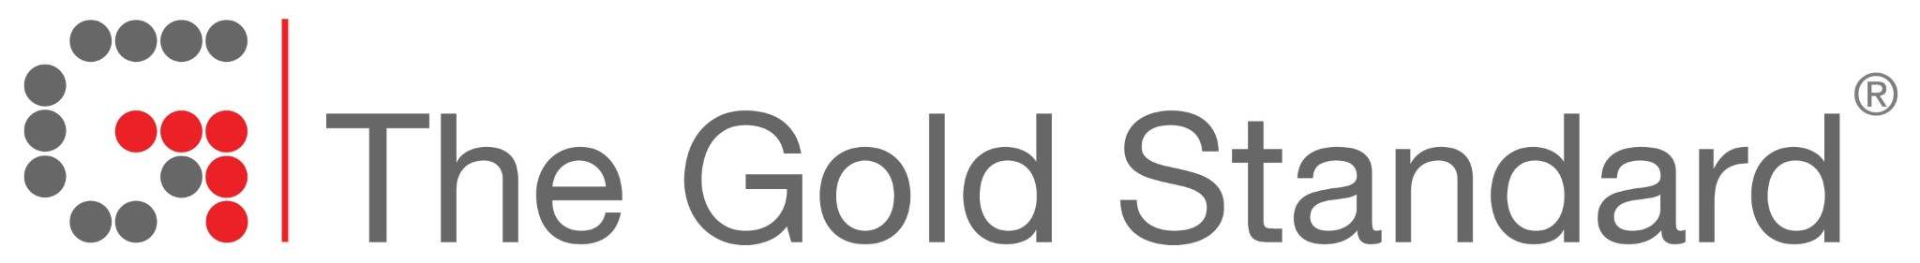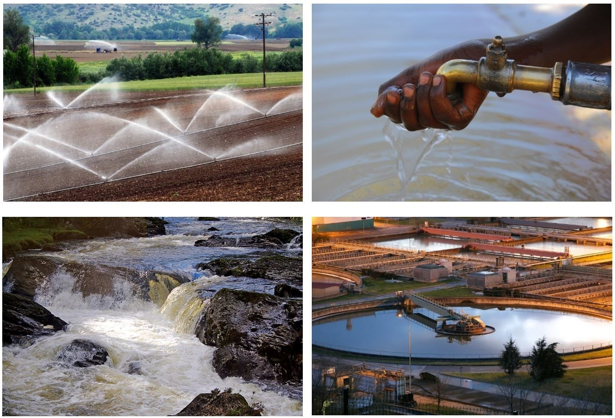

The Gold Standard Water Benefit Standard
Annual Report (beta)

Project Title
...
Gold Standard ID
… e.g. GS-0123
Year of this Annual Report
...

Please outline how your project meets each of the following requirements, referring to any supporting documentation where necessary. The formatting requirements provided in chapter 9 must be followed.

Reporting

- The ‘Annual Report’ shall focus on information since the last ‘Annual Report’. It shall include:
- a summary (in English and local language) of the recent projects activities
- a clear statement (in English and local language) on how stakeholders can provide inputs/grievances
(a) | …
(b) | …

Submit the following documents together with this ‘Annual report’:
(c) | Filled-in template ‘List of Input & Grievances’, listing the input and grievances since the last ‘Annual Report’  …
(d) | Updated ‘Key Project Information’  …
(e) | List of stakeholders who will receive the ‘Annual Report‘  …
(f) | Most recent ‘Certification Report’  …
(g) | Updated ‘Project Participants & Secured Titles’ (in case of any changes)  …

Declaration of correct project information

I hereby certify and declare that, to the best of my knowledge, the project complies with the project information submitted to The Gold Standard.

Project owner
Legal entity:
Name of the organization
Street
Postal code, City
Country

Contact person:
First name, Last name
Position
Mobile phone
Email
Place, Date and Signature
…

