Gold Standard for the Global Goals
Template – Applicability for Afforestation and Reforestation Projects

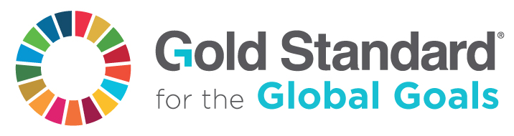

Version 1 – July 2017

SECTION A. PROJECT DESCRIPTION

A. 1. Title of the project
Title:
Date:
Version no.:
Gold Standard ID:

A. 2. Guidelines applied for this certification

A/R Guidelines - Mangroves

SECTION B. APPLICABILITY

- Areas shall not be on wetlands.
Not applicable, as this is a A/R Mangrove Project as per A/R Methodology ‘Section 1.0’
...

- Areas with organic soils shall not be drained or irrigated (except for irrigation for planting).
...

- Soil disturbance (through ploughing, digging of pits, stump removals, infrastructure, etc.) on
organic soils shall be in less than 10% of the area that is submitted to certification (not 10% of the entire project area).
...

- The most likely scenario without the project (baseline scenario) shall be defined for the project area. This scenario shall not show any significant increase of the Baseline biomass (‘tree’ and ‘non-tree’).
...

Wetland Definition of wetland according to the IPCC: ‘This category includes land that is covered or saturated by water for all or part of the year (e.g. peatland) and that does not fall into the forest land, cropland, grassland or settlements categories.’ Source: IPCC - Good Practice Guidance - Wetlands.
Organic soils Organic soils fulfil one of the following requirements: 1. If the soil is never saturated with water for more than a few days, and contains >20% (by weight) of organic carbon (35% organic matter) 2. If the soil is subject to water saturation episodes and has either: - >12% (by weight) organic carbon (20% organic matter) if it has no clay - >18% (by weight) organic carbon (30% organic matter) if it has >60% clay - a proportional lower limit of organic carbon content between 12 and 18% if the clay content of the mineral fraction is between 0 and 60%
Significant Significant is defined to be more than 5% of the ‘long-term CO2-Fixtation’ - see chapter ‘5.7 CO2-Fixation’.

